**Day 13**

**Created a project on Jenkins and give the URL as GUVI capstone project**

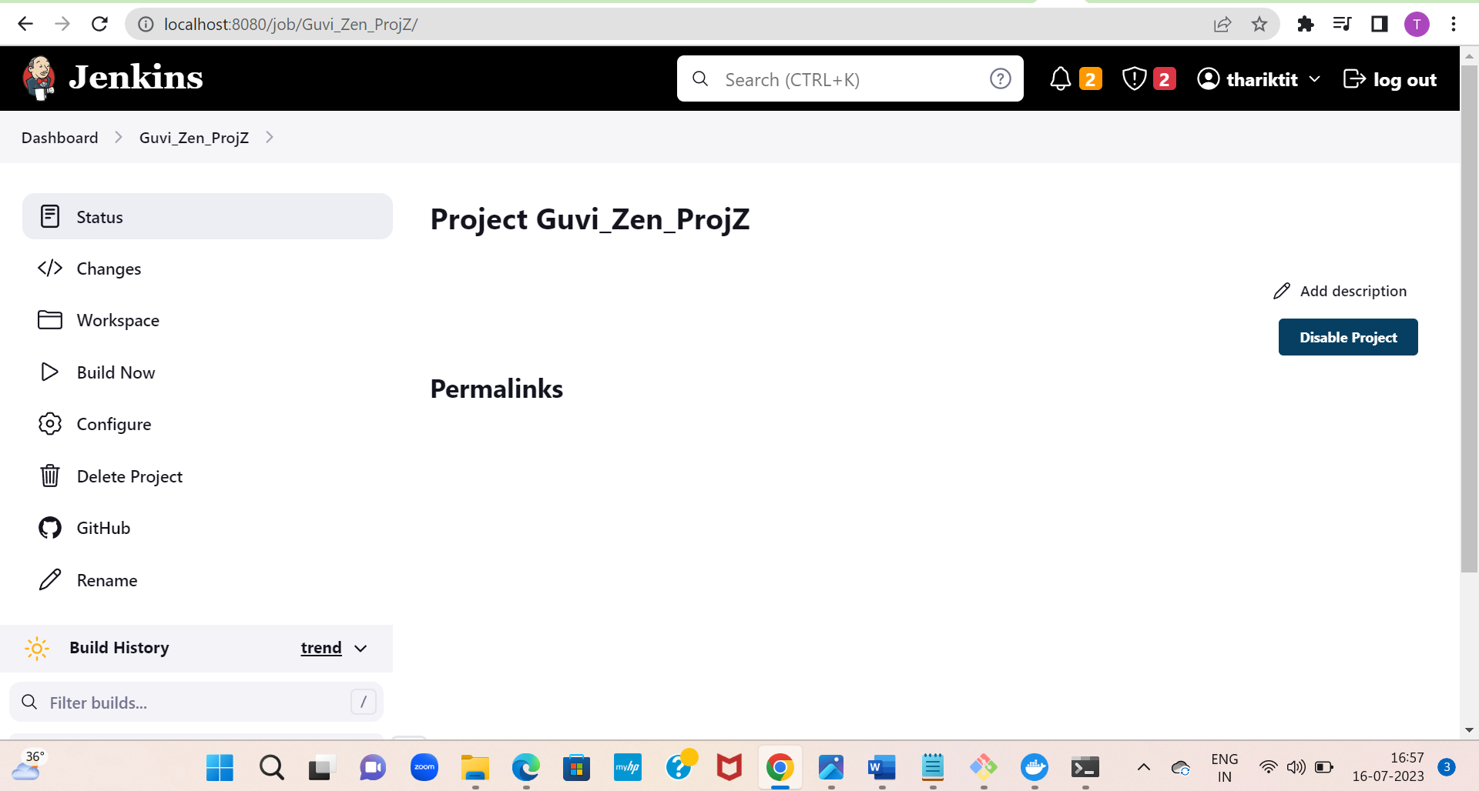

**Managing the Users**

